Juan Franco EECE 212
Lab 7 Working with Image

Lab7 %Running Lab 7 file
Rz %Values for Rz for rotating z axis 30 degrees
Rz = %Values for Rz
0.8660 -0.5000 0
0.5000 0.8660 0
0 0 1.0000
Ry %Values for Ry for rotating y axis 30 degrees
Ry = %Values for Ry
0.8660 0 0.5000
0 1.0000 0
-0.5000 0 0.8660
R1 %Vector formed after rotating z axis 30 degrees
R1 = %Values for R1
1.7321
1.0000
0
R2 %Vector formed after rotating y axis 30 degrees
R2 = %Values for R2
1.7321
0
-1.0000
Lab7 %Running Lab 7 file
diary off %Turning diary off

Plot vector a
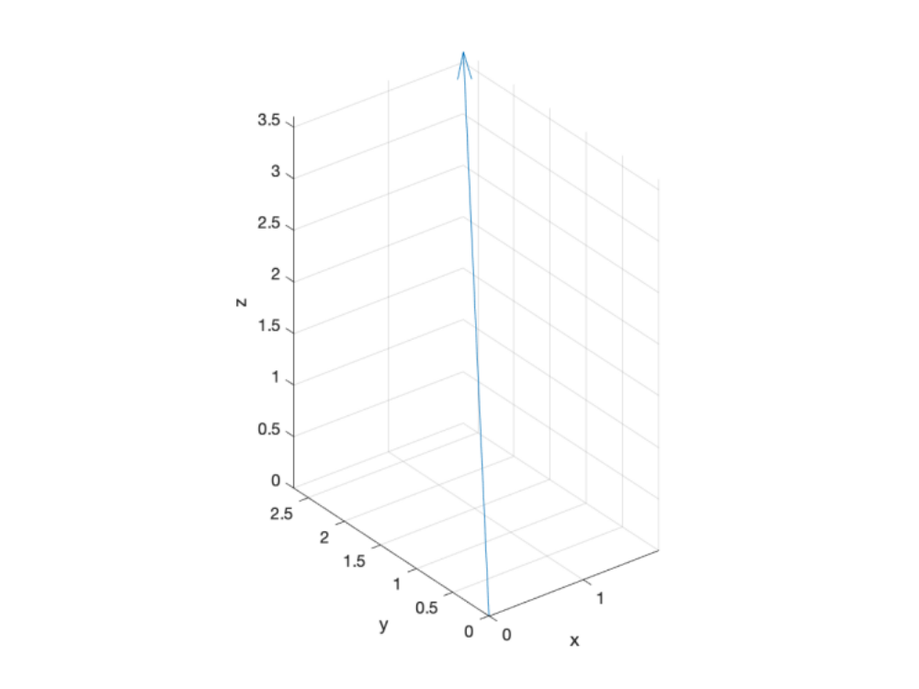

Plot Figure 1.1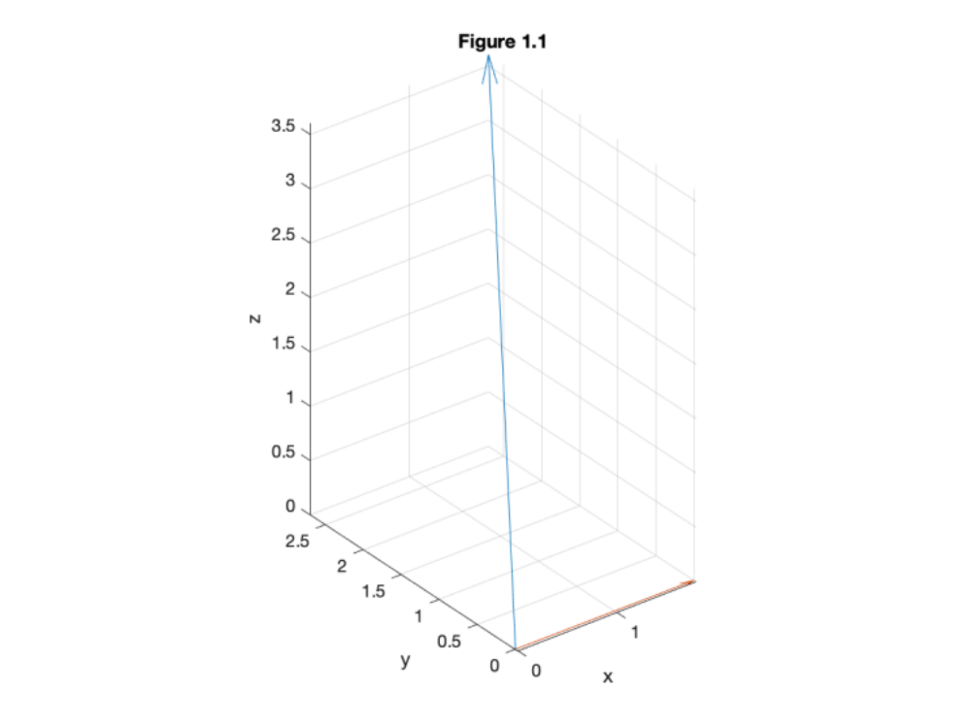

Plot Figure 1.2
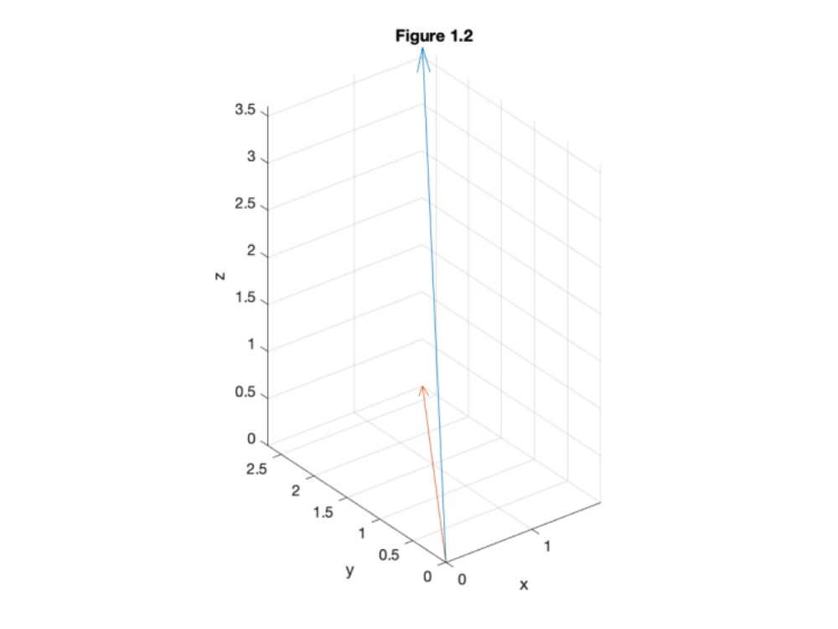

Plot Figure 2.1
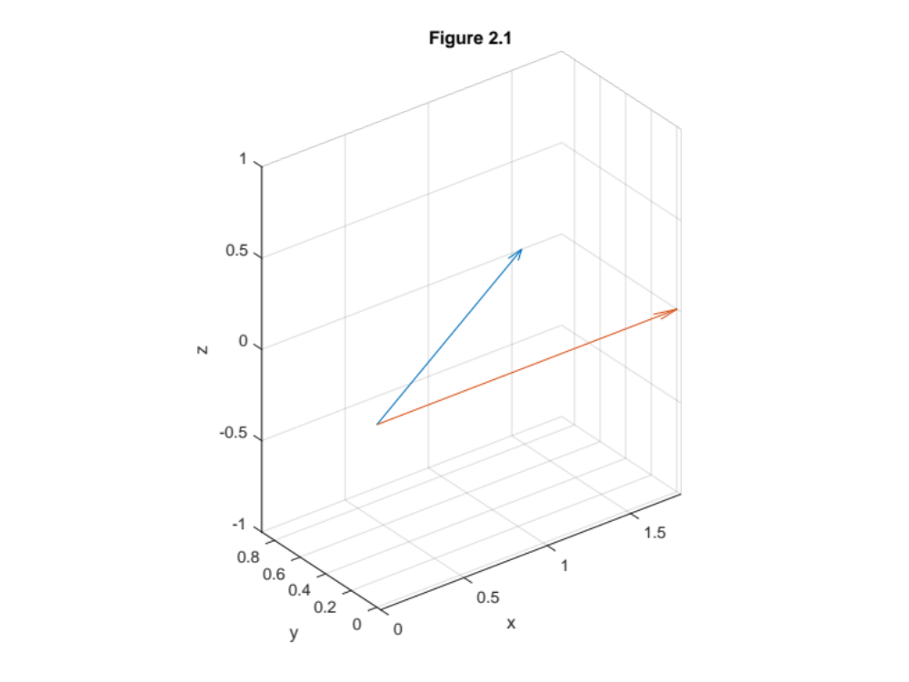

Plot Figure 2.2
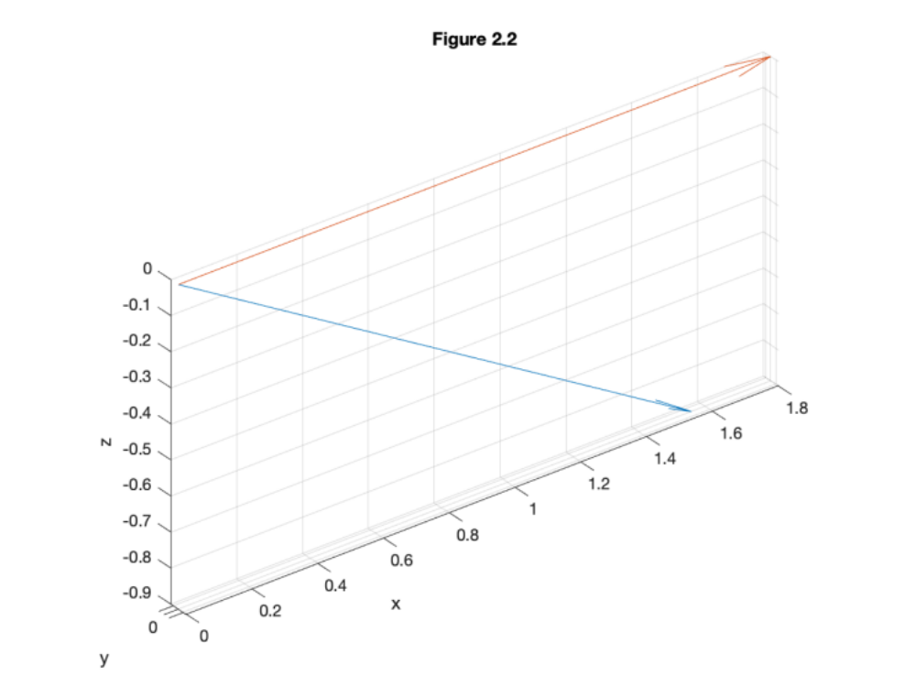

Plot Figure 3.1 Cameraman VS UFO
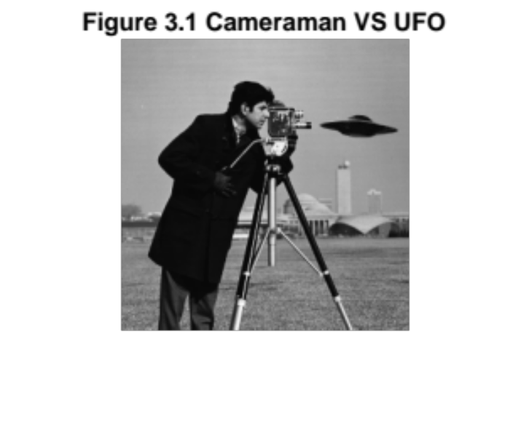

Plot 4 subplot raw, n=2, n=32, n=128
